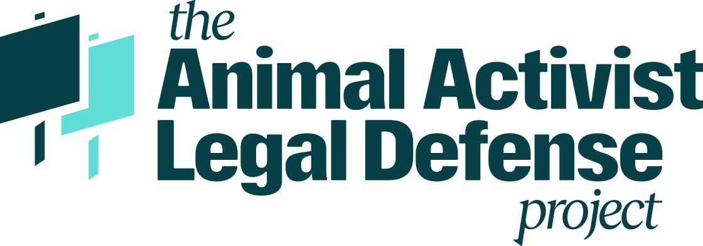

**Volunteer Attorney Sign-Up**

*Thank you* for your interest in working with the Animal Activist Legal Defense Project (AALDP). We are based at the University of Denver Sturm College of Law in Colorado, but we litigate criminal and civil cases across the country and frequently need local counsel. Our mission is to empower and defend animal advocates through activist defense, affirmative litigation, and training law students to join and transform the field of Animal Law. We are endlessly grateful to the attorneys around the country who have collaborated with us on these efforts, and we look forward to working with you.

**Name _______________________________________________________________________**

**Firm Name __________________________________________________________________**

**Location ____________________________________________________________________**

**State(s) where you are admitted _____________________________________________**

**Practice Area(s) _____________________________________________________________**

**Contact info _________________________________________________________________**