WESTERN PLACES | WESTERN SPACES
  - 2025 CONFERENCE • MARCH 6-7 • 2025 • DENVER, CO

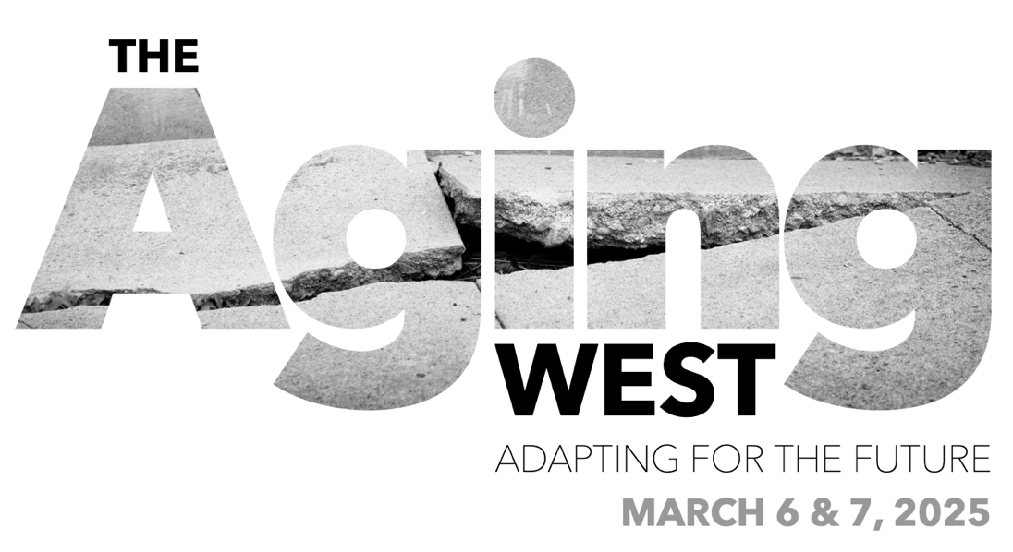
2025 CALL FOR PROPOSALS | SAMPLE FORM

The following sample form can be used to help prepare your proposal offline.
Once you’ve drafted your proposal, please copy/paste responses into the online submission form here.
If you have questions or issues, please email Cindy Lane at: cindy.lane@du.edu.
Proposal submissions are due August 31, 2024.

PLEASE PROVIDE CONTACT INFORMATION FOR YOUR PROPOSAL:
First Name:
Last Name:
Email:
Phone:

PLEASE SELECT THE TYPE OF PROPOSAL YOU ARE SUBMITTING:
(Select One):
Session (panels, roundtables, workshops, & tours)
Individual Speaker

PLEASE SELECT YOUR AVAILABILITY TO PRESENT:
(Select all that apply):
Wednesday, March 5, 2025 (*Wednesday is for workshop proposals only*)
Thursday, March 6, 2025
Friday, March 7, 2025

PLEASE SELECT THE CONFERENCE TOPIC TRACK MOST APPLICABLE TO YOUR PROPOSAL:
(Select all that apply):
Housing
Energy
Water
Transportation & Mobility
Small Towns & Rural Communities
Land Conservation & Open Space
Climate & Disaster Resilience
Legislative Developments & Legal Issues
Tools & Technologies
Equity, Diversity & Inclusion
Professional Responsibility & Ethics

If you are proposing a SESSION,
please provide the following information:

SESSION FORMAT:
(Select one).
Panel Presentation with Moderator
Roundtable Discussion with Moderator
Workshop
Off-Site Tour

SESSION TITLE:

SESSION DESCRIPTION:
Please generally describe what topics your session will cover. If you are proposing an off-site tour, please note the tour location. (This summary will be used for the conference program). (150 words max).

SESSION OUTLINE:
Please provide a detailed outline of how your session will be structured, the topics you plan to address, and the issues that each speaker will cover. Include any points that will help your session provide continuing education credits. (250 word max).

SESSION LEARNING OBJECTIVES:
Please provide at least 3 learning objectives that each attendee should be able to attain by the end of your session. (150 word max).

SESSION AUDIENCE PARTICIPATION:
Please share how your session will engage with audience participants (e.g., audience Q&A, polling, etc.) (100 word max).

SESSION PRESENTER INFORMATION:
Please list the following information for EACH ONE of your session presenters/speakers.
- Name
- Title/Organization
- Location (city/state)
- Email address
- A very brief description of their area of expertise
- Note the topic they will discuss
- Note their role in the session (e.g. moderator, speaker)

If you are submitting a proposal as an INDIVIDUAL SPEAKER,
please provide the following information:

Note: This section is for individuals who would like to submit their name as a potential speaker to be added to our other sessions (panel presentations, roundtable discussions, etc.) Please fill out the information below to help us identify topics and sessions for which you would be a good fit.

SPEAKER NAME:

SPEAKER BIO:
Please provide a short bio explaining your professional qualifications. (250 words max).

SPEAKER AREAS OF EXPERTISE:
For each of the conference topic track areas you selected above, please provide a brief explanation (3-5 sentences) of what you would like to present within that topic area. (250 words max).

SPEAKER LINKEDIN:
If you would like to share your LinkedIn profile URL, please do so here (optional):

