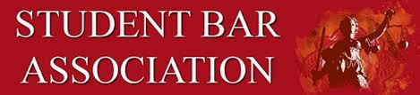
University of Denver Sturm College of Law
STUDENT BAR ASSOCIATION: WEEKLY AGENDA

Date: Wednesday, August 17, 2022, 4:30 – 5:30 PM in room 155
Zoom for meeting:
https://udenver.zoom.us/j/87203666817

- CALL TO ORDER
  - Attendance
    - Exec: Camille Moore, Alexz Thompson, Kelly Lotterhos, Terrie Mankovich, Michael Ozborn
    - ABA: Mariah England
    - Part-Time: Charles Early, Sara Elena
    - 2L: Eliz Espinoza, Caitlin Whaley
    - 3L: Morgan Richardson, Heidi Metroz
  - Team Building
- GUEST SPEAKERS
  - Likely Amber Dannis
- PREVIOUS BUSINESS
  - Derby Days
  - Welcome to the Denver Law Community
- COMMITTEE UPDATES ( will be introductions)
  - Social: Kelly Lotterhos
  - ABA: Mariah England
  - Health & Wellness: Morgan Richardson
  - Community Outreach: Alexz Thompson
  - Finance: Michael Ozborn
  - Diversity: Terrie Mankovich
  - Part-Time: Mariah England
- NEW BUSINESS
- STUDENT CONCERNS
- CALENDAR
  - August 15: First Day of Class
  - August 20: Derby Days- 11am- 2pm
  - August 27th: Welcome to the Denver Legal Community 12:30- 3:30pm
- REMARKS FOR THE GOOD OF THE ORDER
- MOTION TO ADJOURN

